**Incremental Data Loading Pipeline Documentation**

**Goal**

Implement an incremental data loading strategy to process only new records from incoming CSV files, and maintain a cumulative dataset without duplications — based on a unique key (Code).

**Folder Structure**

Create the following directories on your Ubuntu machine:

*mkdir -p ~/Downloads/csv_incremental/data/new*

*mkdir -p ~/Downloads/csv_incremental/data/processed*

Where to place files:

Drop new CSV files (e.g. DimenLookupEthnic8277.csv) in:

*~/Downloads/csv_incremental/data/new/*

The script will maintain a cumulative processed file at:

*~/Downloads/csv_incremental/data/processed/processed_dimen_lookup.csv*

**Script: incremental_loader.py**

Save the following script to:

*~/Downloads/csv_incremental/incremental_loader.py*

*import os*

*import pandas as pd*

*new_data_dir = os.path.expanduser("~/Downloads/csv_incremental/data/new")*

*processed_file_path = os.path.expanduser("~/Downloads/csv_incremental/data/processed/processed_dimen_lookup.csv")*

*if os.path.exists(processed_file_path):*

*processed_df = pd.read_csv(processed_file_path, dtype=str)*

*print(f"[INFO] Loaded existing processed file with {len(processed_df)} rows.")*

*else:*

*processed_df = pd.DataFrame(columns=["Code", "Description", "SortOrder"])*

*print(f"[INFO] No processed file found. Starting fresh.")*

*for filename in os.listdir(new_data_dir):*

*if filename.endswith(".csv"):*

*file_path = os.path.join(new_data_dir, filename)*

*print(f"[INFO] Processing {filename}...")*

*new_df = pd.read_csv(file_path, dtype=str)*

*new_df = new_df.dropna(subset=["Code"])*

*new_rows = new_df[~new_df["Code"].isin(processed_df["Code"])]*

*print(f"[INFO] Found {len(new_rows)} new rows.")*

*if not new_rows.empty:*

*processed_df = pd.concat([processed_df, new_rows], ignore_index=True)*

*processed_df.to_csv(processed_file_path, index=False)*

*print(f"[INFO] Updated processed file saved with {len(processed_df)} total rows.")*

**How to Run the Pipeline**

*cd ~/Downloads/csv_incremental*

*python3 incremental_loader.py*

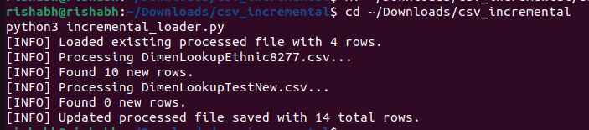

**Example of Incremental Load**

Initial state:

processed_dimen_lookup.csv has 11 rows from DimenLookupEthnic8277.csv.

New File:

Create a test file DimenLookupTestNew.csv in data/new/:

*Code,Description,SortOrder*

*9999,Total people,1*

*1,European,2*

*NEW-001,New Entry 1,1*

*NEW-002,New Entry 2,2*

Run the Script Again:

*python3 incremental_loader.py*

Expected Output:

[INFO] Loaded existing processed file with 11 rows.

[INFO] Processing DimenLookupTestNew.csv...

[INFO] Found 2 new rows.

[INFO] Updated processed file saved with 13 total rows.

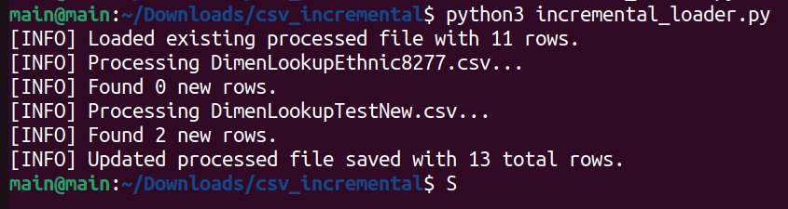



**Outcome**

This pipeline:

* Ingests new data from CSVs
* Filters out duplicates using Code as a unique identifier
* Appends only new rows to a persistent output file